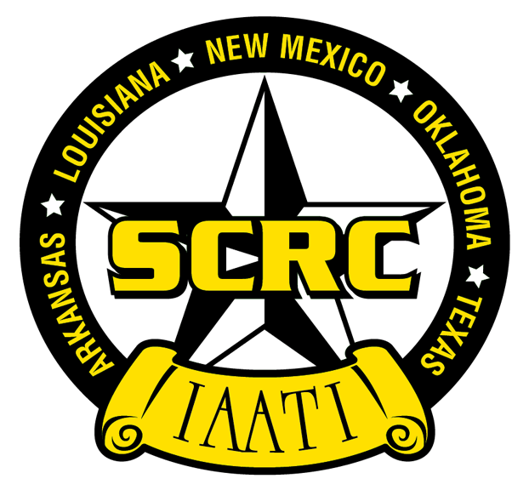 | International Association of Auto Theft Investigators  South Central Regional Chapter (SCRC)  2016 Annual Training Conference | 
October 24 – 28, 2016
Marriott Northwest Hotel
3233 NW Loop 410, San Antonio, TX 78213
Phone: 210-377-3900

Dear Law Enforcement Supporter:

Please accept this invitation to partner with the Texas Association of Vehicle Theft Investigators and the South Central Regional Chapter of the International Association of Auto Theft Investigators (TAVTI/SCRC) in hosting the 2016 SCRC/TAVTI Annual Training Conference in San Antonio, Texas, October 24 – 28, 2016. The TAVTI/SCRC was founded in 1975, and our membership includes officers of all ranks from police departments, sheriffs’ departments, constables’ offices, the Texas Department of Public Safety, Texas government agencies and insurance companies. Through training, exchange of information, and various recognition programs, TAVTI/SCRC is dedicated to upgrading the efficiency and professionalism of all Texas law enforcement officers that are involved in the investigation and prevention of vehicle crimes.

We are very excited to be conducting this year’s training conference at the Marriott Northwest Hotel in San Antonio, Texas. Many excellent training sessions and social activities are scheduled for attendees, and a large turnout of law enforcement, public safety, and stakeholder officials is anticipated, with attendance likely to be approximately 200 individuals.

We are seeking exhibitors and sponsors from all areas of industry and business that have an interest, either directly or indirectly, in vehicle loss prevention, law enforcement, public safety, or the transportation industry. One of the unique aspects of this event is that officers of various ranks and from various agencies will be attending. Decision makers, such as task force commanders, as well as patrol officers and detectives will be in attendance. This cross-section of attendees provides an excellent venue in which to showcase your product, service or organization name.

Enclosed is a vendor/exhibitor registration form and information about the various levels of sponsorship that are available. Our vendors and supporters tell us that they consider the TAVTI/SCRC annual conference to be a tremendous marketing opportunity.

On behalf of the Texas Association of Vehicle Theft Investigators and the International Association of Auto Theft Investigators South Central Regional Chapter, I would like to thank you for your consideration and support. Should you have questions, please feel free to contact me via phone, 512-589-8803, or
e-mail, bbailey@co.guadalupe.tx.us. We look forward to seeing you!

Sincerely,

Bobby Bailey
2015/2016 SCRC/TAVTI President

International Association of Auto Theft Investigators
South Central Regional Chapter (SCRC)
2016 Annual Training Conference
October 24 - 28, 2016
Exhibit Dates: October 26 - 27 , 2016
Marriott Northwest Hotel
3233 NW Loop 410, San Antonio, TX 78213
Phone: 210-377-3900

2016 TAVTI/SCRC VENDOR-EXHIBITOR REGISTRATION

Each vendor/exhibitor is allowed two (2) representatives.

The vendor/exhibitor booth fee of $350 allows both representatives to attend all conference events from October 24 to October 28, except the golf tournament, at no additional charge. A third vendor/exhibitor representative may share the same privileges at an additional cost of $50.

As a vendor/exhibitor, you are vital to our program and will receive our full cooperation. The Marriott Northwest is the venue for all conference sessions and exhibitor displays. Certain general membership and attendee functions will be in the exhibitor area, thus maximizing contact between exhibitors and attendees. If your registration is received by August 31, 2016, your company name and information will be listed in the conference notebook and in the conference issue of The SlamHammer magazine.

Exhibitor booths will be equipped with one skirted 30” x 6’ table and two chairs, and will measure at least 10’ X 5’. If electricity or phone lines are needed for the booth, it will be the exhibitor’s responsibility to contact the hotel and make such arrangements (hotel phone: 210-377-3900).

Exhibit set-up will take place Tuesday, October 25th, 2016, between 8 a.m. and 5 p.m.

Exhibit hours will be Wednesday, October 26th, 2016, from 8 a.m. to 5 p.m. and Thursday, October 27th, 2016, from 8 a.m. to 4 p.m.

Exhibit tear-down must be completed by 5 p.m. on Thursday, October 27th, 2016. Exhibitors that may need to tear down prior to Thursday at 5 p.m. will not be penalized.

Exhibitor booths can be reserved by remitting the full amount of $350 not later than September 30, 2016. Checks should be made payable to “TAVTI,” and should be forwarded along with the attached registration form to: SCRC/TAVTI, P.O. Box 1739, Lubbock, TX 79408. Visa & MasterCard are also accepted. Exhibitor booth space is limited and will be reserved on a “first received – first reserved” basis. Refunds cannot be considered after September 30, 2016. There is no space for vehicle displays inside the exhibit area, but space may be available in the parking area surrounding the hotel.

Hotel reservations can be made by contacting the Marriott Northwest Hotel at 210-377-3900. A room rate of $115 (single) or $120 (double) per night is available for SCRC/TAVTI attendees for the conference dates by referring to the Texas Association of Vehicle Theft Investigators as your group when making phone reservations, or use corporate code “TAVN” when making online reservations at http://www.marriott.com/hotels/travel/satnw-san-antonio-marriott-northwest. Registration deadline for receiving the special room rate is September 20, 2016.
---------------------------------------------------------------------------------------------------------------------------------------------------------
REGISTRATION FORM

Yes, count me in as an exhibitor. Below is our organizational information.
Company Name: Contact:

Mailing Address:
City: State: Zip:
Phone: Fax:

Cell: E-mail:
International Association of Auto Theft Investigators
South Central Regional Chapter (SCRC)
2016 Annual Training Conference
October 24 - 28, 2016
Exhibit Dates: October 26 - 27, 2016
Marriott Northwest Hotel
3233 NW Loop 410, San Antonio, TX 78213
Phone: 210-377-3900

PRIMARY BOOTH REPRESENTATIVE:
(Name badges will be made from this information, so please type or print)

Name:
Company:
Address:
City: State: Zip:

Phone: E-mail:

ADDITIONAL BOOTH REPRESENTATIVE(S):

Name:
Company:
Address:
City: State: Zip:

Phone: E-mail:

ADDITIONAL BOOTH REPRESENTATIVE(S) - $50 charge:

Name:
Company:
Address:
City: State: Zip:

Phone: E-mail:

International Association of Auto Theft Investigators
South Central Regional Chapter (SCRC)
2016 Annual Training Conference
October 24 - 28, 2016
Exhibit Dates: October 26 - 27, 2016
Marriott Northwest Hotel
3233 NW Loop 410, San Antonio, TX 78213
Phone: 210-377-3900

2016 TAVTI/SCRC SPONSOR REGISTRATION

GENERAL SPONSORSHIP OPPORTUNITIES
GOLD LEVEL $2,000 | SILVER LEVEL $1,000 | BRONZE LEVEL $500
- One exhibitor booth space  - Company name and logo on display as Gold Sponsor at conference  - Gold Sponsor recognition and ¼ page ad in conference notebook  - Recognition as a Gold Sponsor with company logo and link to your corporate home page on www.tavti.org for 9 months  - Your name in one issue of the SlamHammer magazine | - Company name on display as Silver Sponsor at conference  - Silver Sponsor recognition in conference notebook  - Recognition as a Silver Sponsor with company logo and link to your corporate home page on www.tavti.org for 6 months  - Your name in one issue of the SlamHammer magazine | - Bronze Sponsor recognition in conference notebook  - Recognition as a Bronze Sponsor and link to your corporate home page on www.tavti.org for 3 months  - Your name in one issue of the SlamHammer magazine

EVENT SPONSORSHIP OPPORTUNITIES
- Coffee Breaks (4 breaks) $ 500 each (signage at conference)
- Hospitality Room Sponsor $ 500 (signage at conference)
- Golf Tournament Hole Sponsor $ 100 (signage at golf tournament)
- Door Prize Donor $ 0 (signage at conference)

SPONSORSHIP INFORMATION:

Sponsorship Organization:
Sponsorship Contact Person:
Sponsorship Mailing Address:
City: State: Zip:
Contact Phone: Contact Email:

Brief Description of Sponsor Product/Services/Door Prize Donation:
Please complete worksheet on following page to indicate sponsor/vendor levels of interest

International Association of Auto Theft Investigators
South Central Regional Chapter (SCRC)
2016 Annual Training Conference
October 24 - 28, 2016
Exhibit Dates: October 26 - 27, 2016
Marriott Northwest Hotel
3233 NW Loop 410, San Antonio, TX 78213
Phone: 210-377-3900

2016 TAVTI/SCRC SPONSOR/EXHIBITOR PAYMENT WORKSHEET

ITEM | AMOUNT | ENCLOSED
SPONSOR PACKAGES
Gold Level | $2,000
Silver Level | $1,000
Bronze Level | $500
EVENT SPONSOR OPPORTUNITIES
Hospitality Room Sponsor | $500
Coffee Break Sponsor (4 breaks to be held – price listed is for one break) | $500
Golf Tournament Hole Sponsor | $100
Door Prize Donor (please indicate type/# of items on previous page) | $0
EXHIBITOR/VENDOR BOOTHS
Booth Space (includes one 6’ table, two chairs, two reps) | $350
Additional (third) Booth Representative | $ 50
Vehicle Space (outside) | no charge
Total Amount Enclosed (all categories) |  | $

[ ] Payment by Check

Make checks payable and mail to: TAVTI/SCRC
AND/OR Send door prizes to: Attn.: Kat Anderson
P.O. Box 1739
Lubbock, TX 79408
E-mail: texkat52@yahoo.com

[ ] Payment by Credit Card

If you would like to pay using a credit card, fill out the following information and fax to TAVTI/SCRC, attention Kat Anderson, at 806-787-5133, or e-mail to texkat52@yahoo.com.

[ ] MasterCard [ ] Visa
Name (on card): Card Number:

Security Code (3 digits on back) : Exp. Date: Billing Zip Code:

Cardholder Signature: _______________________________________ Today’s Date:

Please return this page with all completed forms reflecting your registration and participation

